CURRICULUM VITAE OF RYAN SMITH
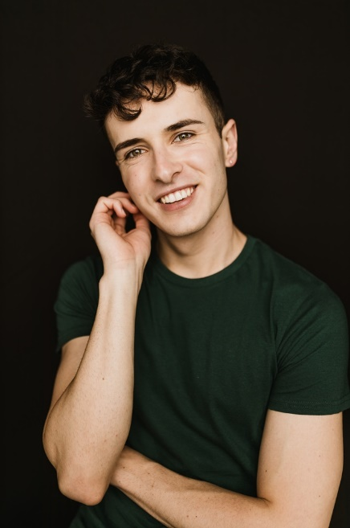 |  | gender: | Male
 |  | age: | 23
 |  | height: | 178 cm
 |  | waist: | 28/ 30 inch
 |  | hips: | 33 inch
 |  | shoe: | 8
 |  | hair: | Dark brown
 |  | eyes: | Hazel
 |  | languages: | English.  Afrikaans (1st additional language)
 |  | accents: | Straight South African  Afrikaans  Straight General American
SKILLS
Dance (Contemporary, Hip Hop, Freestyle solo). Singing (Baritone). Radio and TV Presenting, Swimming, Horse-riding
TERTIARY EDUCATION
year | qualification |  |  | institution
2023 | BA Honours in Theatre and Performance |  |  | Wits
2021 | Bachelor of Drama |  |  | University of Pretoria
THEATRE EXPERIENCE
year | production |  |  | role
2023 | Momo’s Magical Adventure  Sandton City |  |  | Various
2023 | Peppa Pig  Touring SA production |  |  | Various
2021 | Hello and Goodbye |  |  | Johnny
2021 | M. Butterfly |  |  | Song - Adaptation
2021 | The Pen |  |  | Sam
2020 | Miss Saigon |  |  | Chris
FILM, TV & COMMERCIAL EXPERIENCE
year | production |  |  | role
2022 | Sterkinekor TVC |  |  | Featured
2020 | Super M – Social Media Campaign |  |  | Lead
2019 | K.P.H.H. |  |  | “Ryan”
OTHER EXPERIENCE
year | production |  |  | role/position
2019-2021 | Tuks FM 107.2 |  |  | Presenter
2021 | Jumpers and Anchors |  |  | Director
2021 | Five FM Pride Segment |  |  | “Anonymous Queer Person”
2019 | Kopanong Student Art Festival |  |  | Stage Manager

